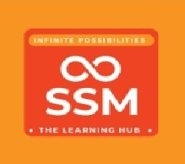School Students Visit to SSMIET Library-

January 2024

**Students from Vedasanthur Government Boys Higher Secondary School and Nehruji Memorial Dindigul Corporation Higher Secondary School embarked on an educational visit to the SSMIET Library. The purpose of the visit was to acquaint the students with the library facilities and to foster an interest in utilizing these resources for academic and personal growth.**

**Objective:**

**The primary objective of the visit was to provide students with a first and experience of the SSMIET Library, enabling them to explore the diverse range of resources and services offered.**